

CSE3002 – FINAL REPORT

**HOUSE RENTAL MANAGEMENT SYSTEM**

**Team Members:**

1. **ABHIRAM BORIGE 19BCI0005**
2. **VENKATA SAI MOHAN 19BCI0019**
3. **SHAIK RUMAAN 19BCI0056**
4. **BHANU PRAKASH 19BCI0057**

Date: 9th December 2021

This project is **completed**

**Under the guidance of**

**Professor Lydia Jane G**

# TABLE OF CONTENTS

Abstract 3

Introduction 4

Property Modules 5

Features of Property Module 5

Features of Login Module 5

Functionality and modules of the project 6

Technology used in the project 7

Output details 8

Use case Diagram 9

System implementation 10

Admin login page 10

Conclusion 11

References 12

# ABSTRACT

A majority of unpleasant issues faced by landlords and tenants seem to grow due to lack of communication. Late rent payments turn into an eviction. A non-functional AC or a broken window becomes a reason to break a lease. Fortunately, building a positive relationship doesn't take much effort and it all starts with one basic idea: communication. Rental Property Management website provides the solution by offering the ability to share issues between tenants and landlords which leads to rapid issue resolution and fewer misunderstanding. The goal of the website is to create a better relationship between tenants and landlord. The Rental Property Management website is designed to support both tenants and landlords by enabling them to document and communicate repair issues, send automatic rent reminders, package notifications and emergency information. It helps the tenant with making Payments and it also helps the Landlord to keep track of issues posted by tenants. Effectively resolving the apartment issues is important to the tenant's long- term future and the Rental Property Management website will be an important tool for creating rental housing stability by helping tenants speak with greater credibility through initiating and documenting communications and building productive relationships with landlords.

# INTRODUCTION

Rental house management has become important factor in modern society hence the need to have a rental house management system. House Rental is a house/Apartment/home that can be used temporarily for a fee during a specified period. The individual who needs a house must contact a rental car company and contract out for a room/home/ apartment. This system increases customer retention and simplify House and staff management. A House rental is a house that can be used temporarily for a period of time with a fee. Renting a house assists people to live in a comfortable house when they do not have access to build their own personal homes/houses or.

The individual who wants to rent a bouse/root/apartment/home must first contact the House rental company for the desire House/Home apartment. This can be done online. At the point this person has to supply some information such a date of rental, and type of house. After these details are worked out the individual renting the house must present a valid Identification Card Most companies throughout the industry make a profit based of the type of house that are rented the rental houses are categorized into modem Homes, Colonial. apartment, Rentals etc. And customers are free to choose any house of their choice hazed on their pun and availability of such houses in the time of booking.

# PROPERTY MODULE

The main aim of this module is providing all the details functionality related to Property. We have developed all type of CRUD (Create, Read, Update and Delete) operations of the Property. This Property Module is an important module in this mini project House Rental System which has been developed on PHP and MySQL. Student can get complete php projects with source code and documentation free download.

FEATURES OF PROPERTY MODULE

• Admin can add new Property records

• Admin can see the list of Property details

• Only admin can edit and update the record of the Property

• Admin will be able to delete the records of the Property

• All Property forms are validated on client side using JavaScript

FEATURES OF LOGIN MODULE

• Admin can add new Login records

• Admin can see the Login details

• Only admin can edit and update the record of the Login

• Admin can change the password

# FUNCTIONALITY AND MODULES OF THE PROJECT

• Login - This module is used for admin login

• Logout Functionality

• Change Password Functionality

• Dashboard - Admin dashboard related all Property, Property detail Property listing

• Property Management Module

• Adding New Property Details

• Edit the Exiting Property Details

• View all the details of the Property

• Listing of all Property

• Property Type Module

• Adding New Property Type Details

• Edit the Exiting Property Type Details

• View all the details of the Property Type

• Listing of all Property Type

• Reports of the project House Rental System

• Report of all Property.

• Report of all Property Type

# TECHNOLOGY USED IN THE PROJECT

We have developed this project using the below technology

• HTML: Page layout has been designed in HTML

• CSS: CSS has been used for all the designing part

• JavaScript: All the validation task and animations has been developed by JavaScript

• PHP: All the business and frontend logic has been implemented in PHP

• MySQL: MySQL database has been used as database for the project

• Apache2: Project will be run over the Apache2 server

# OUTPUT DETAILS

• Home Page:

• Owner Registration Page:

• House Owner login Page:

• House Owner home Page:

• View Owner profile page:

• Add House details:

• View added House details:

• Client login:

• Client Home:

• View owner and activate:

• View user and activate:

• Customer Registration:

• Customer Login:

• Customer Home Page:

• View Profile Page:

• Search Houses:

• Results Page:

• About us:

# USECASE DIAGRAM

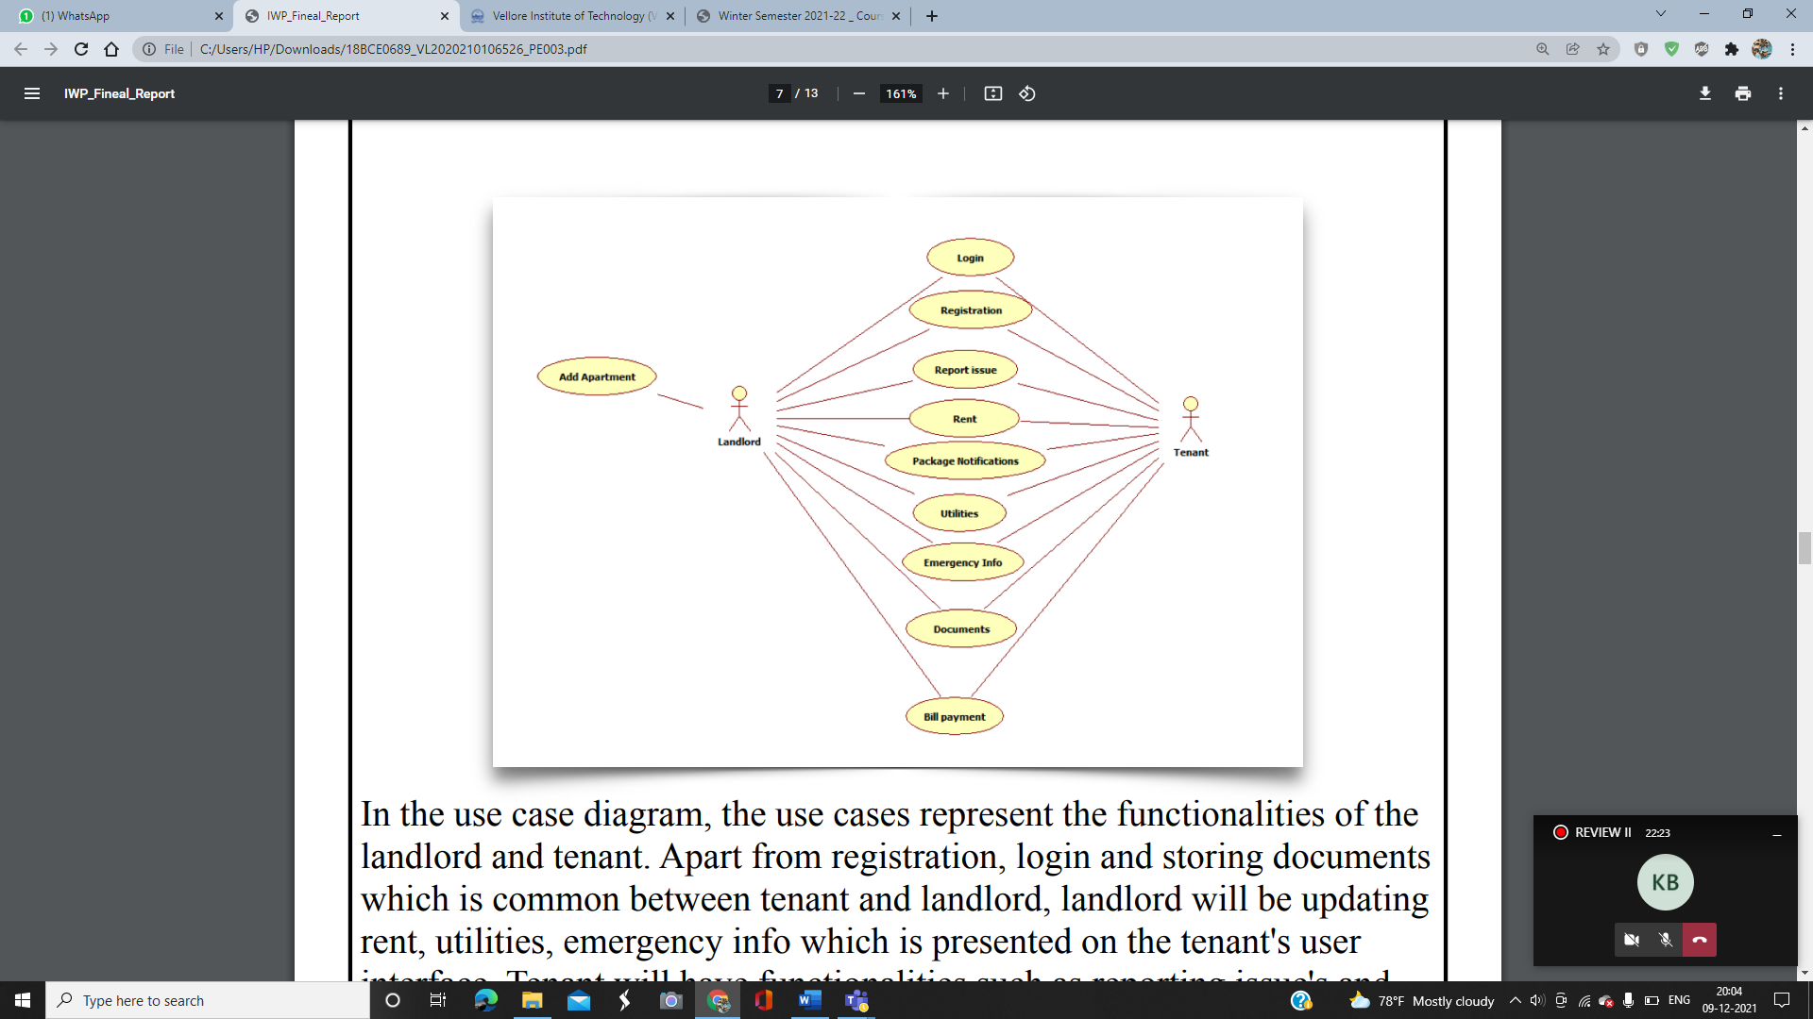

In the use case diagram, the use cases represent the functionalities of the landlord and tenant. Apart from registration, login and storing documents which is common between tenant and landlord, landlord will be updating rent, utilities, emergency info which is presented on the tenant's user interface. Tenant will have functionalities such as reporting issues and bill payment which is displayed on landlord's screen.

# SYSTEM IMPLEMENTATION

ADMIN LOGIN PAGE